Scenario 7: Securely Connecting to EC2 Windows Instances (RDP vs Session Manager)
To connect to windows server, we need to follow many steps.
First mainly generate a password with the key pair.
Case 1- Connect via RDP (using key pair) {not recommend}
Step 1: select on the windows instance > click on connect.
Navigate to RDP Client
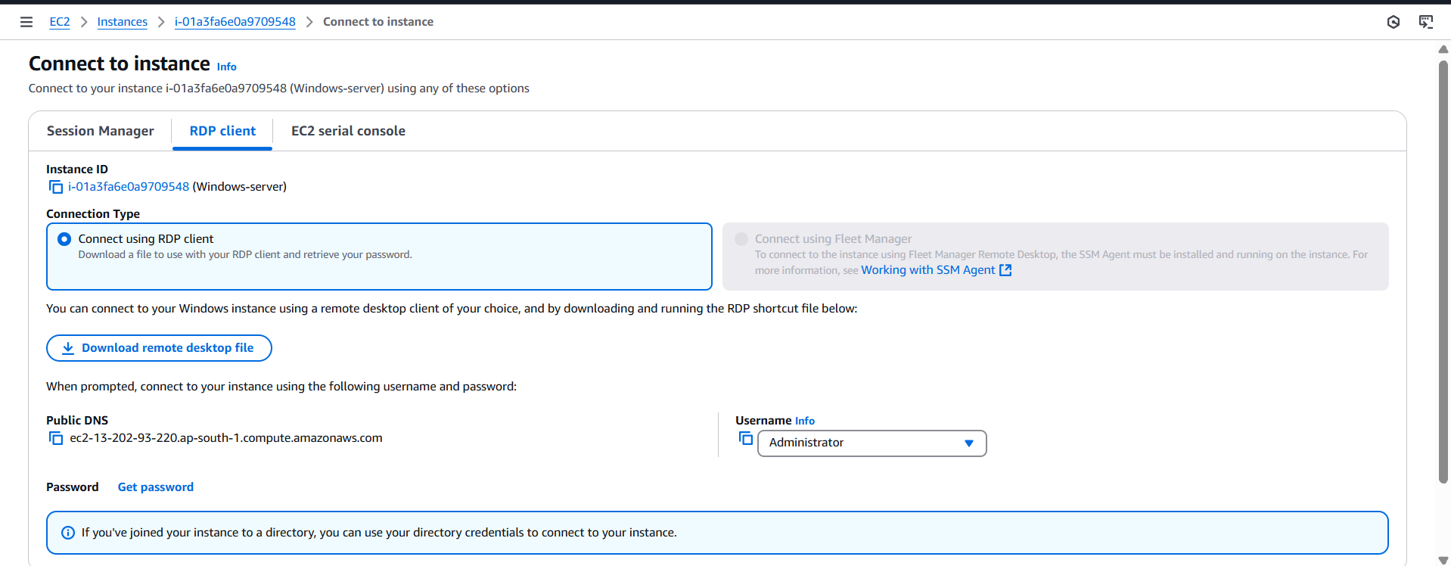
Step 2: to generate a password
Scroll down and click on Get Password.
Upload the key file (.pem) and click on Decrypt password.
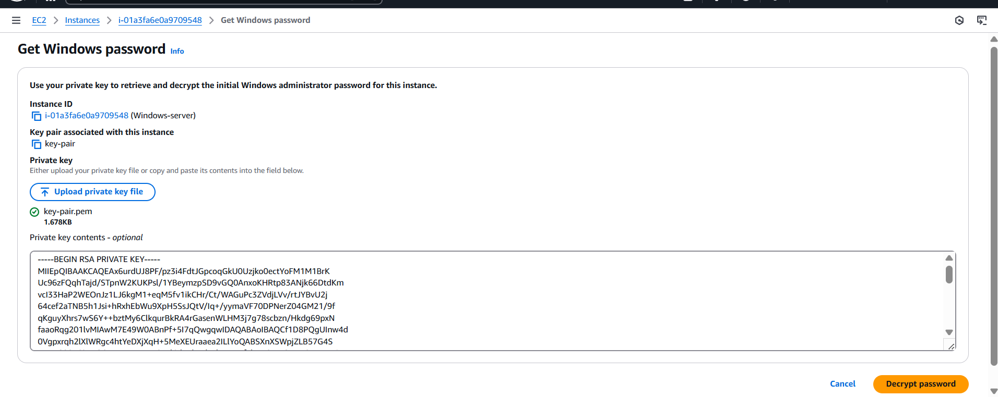
Step 3: copy the password.
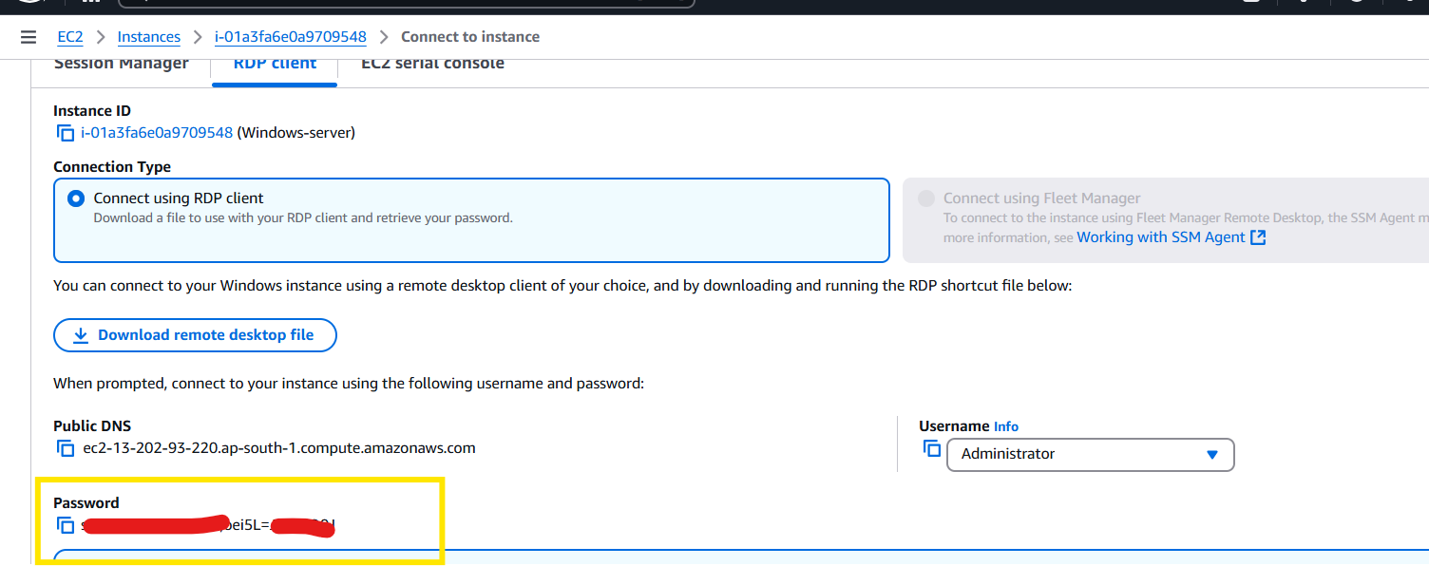

If you already have the username and password, then follow the below steps.
Case 2-Connect via Session Manager (no RDP file)
Step 1: Prerequisites
- The instance must have an IAM role with the policy AmazonSSMManagedInstanceCore.
- Instance must be able to reach AWS Systems Manager endpoints over HTTPS (443).
- Either via internet access + NAT Gateway (for private subnets), or
- Via VPC endpoints (ssm, ssmmessages, ec2messages) for fully private connectivity.
- SSM Agent must be installed and running (preinstalled on most Amazon AMIs).
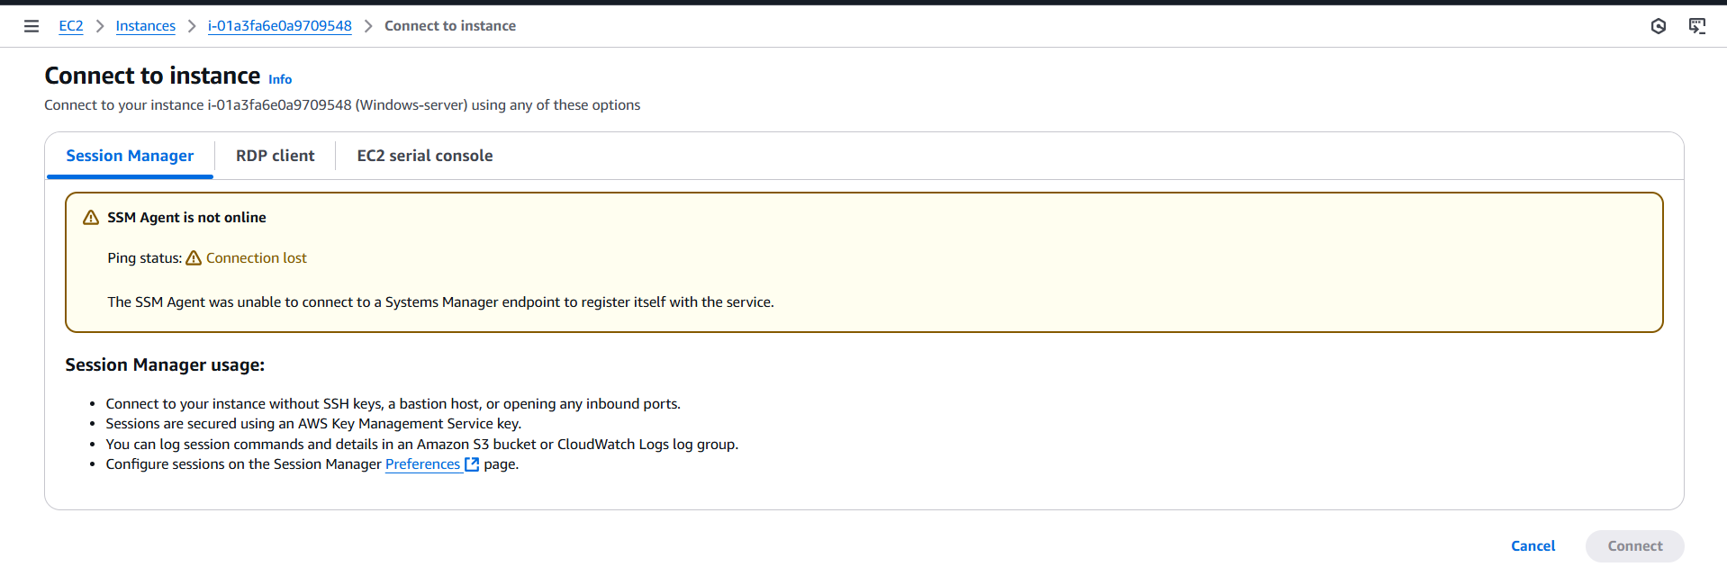
Step 1: attach iam role
select the instance > security > Modify IAM role.
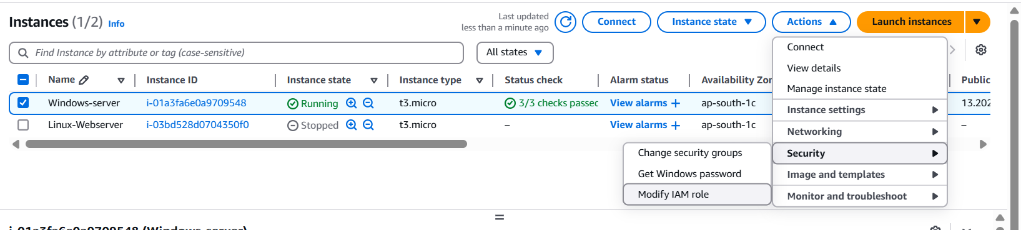
Step 8: click on create role if we don’t have create a role – SSM-role with permission – AmazonSSMManagedInstanceCore.
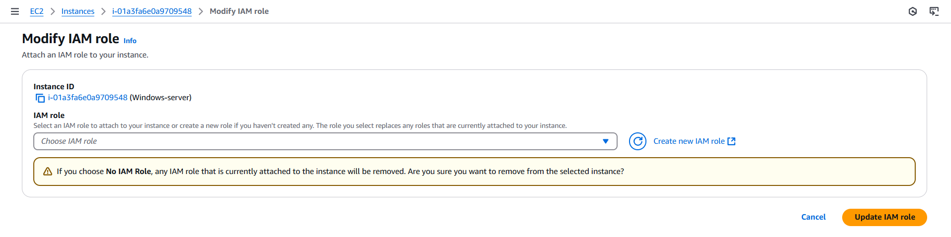
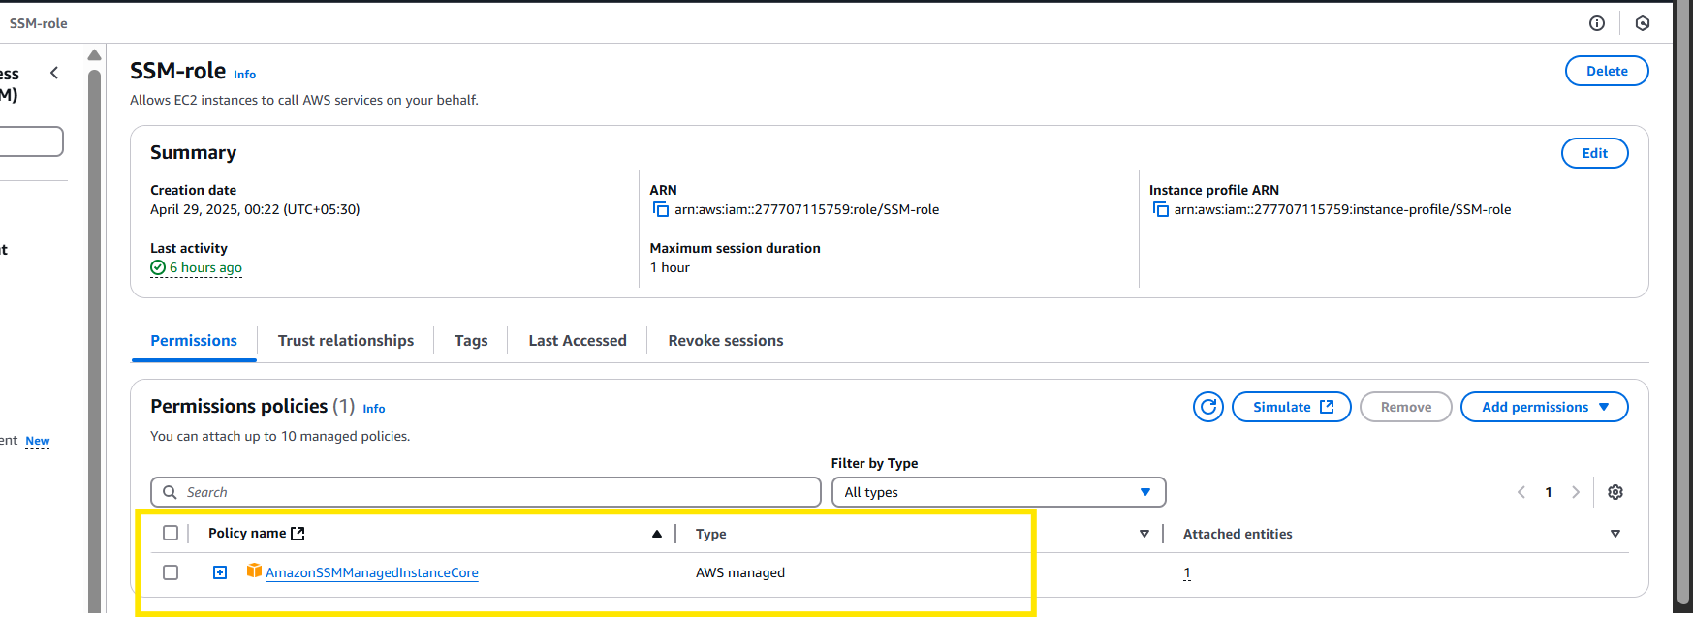
Once done select that role and click on update IAM role
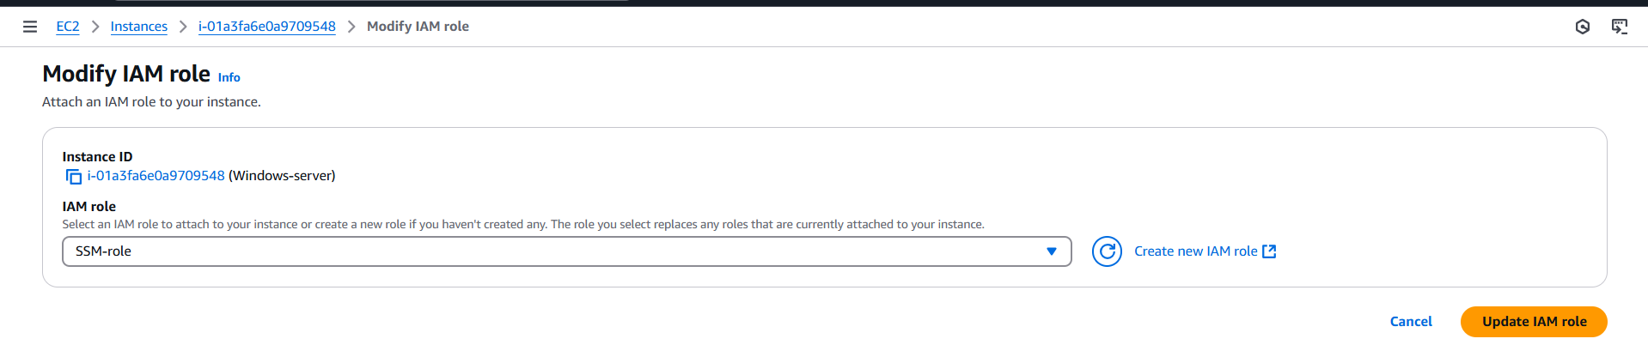
Usually, it takes time (10-15mins or even more, so usually you login to server an check for the agent status or else if you leave it as it is, it takes like 15mins) for a SSM agent to come up. once it’s up you can view here
Now we could see that error is gone.
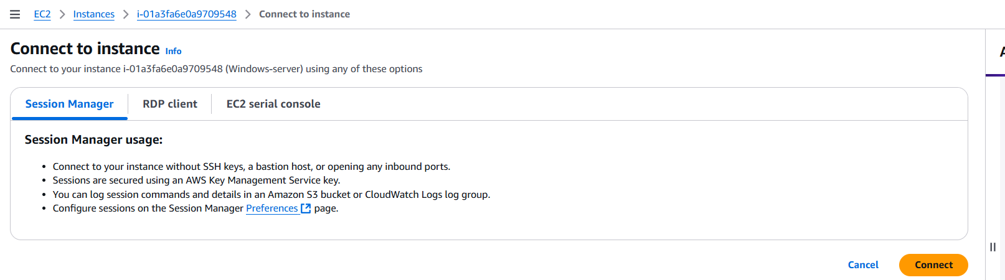
If you click on connect you will be connected to CLI session.
Step 9: if you want to connect to RDP
Go to system Manager > fleet Manager > under managed node you will notice the windows server.
Select the instance > node actions > connect > connect with remote desktop.
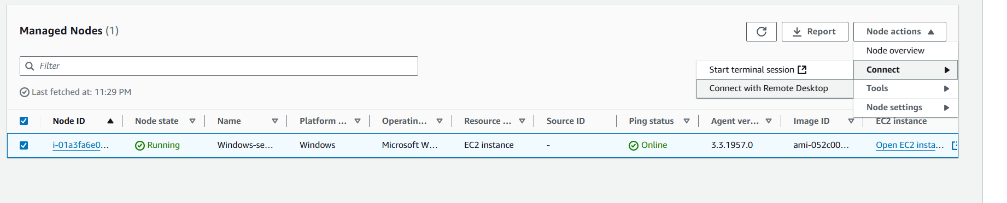
Step 10: you can provide the username and password or authenticate via key pair also.
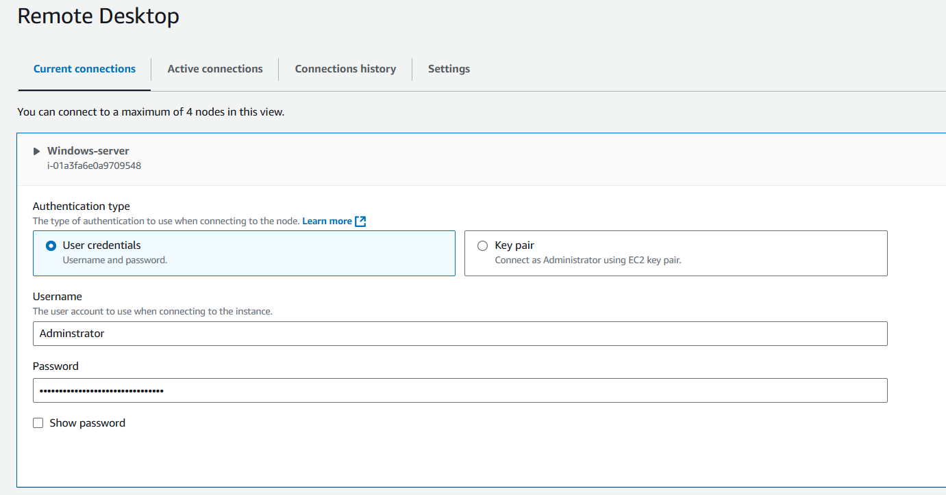
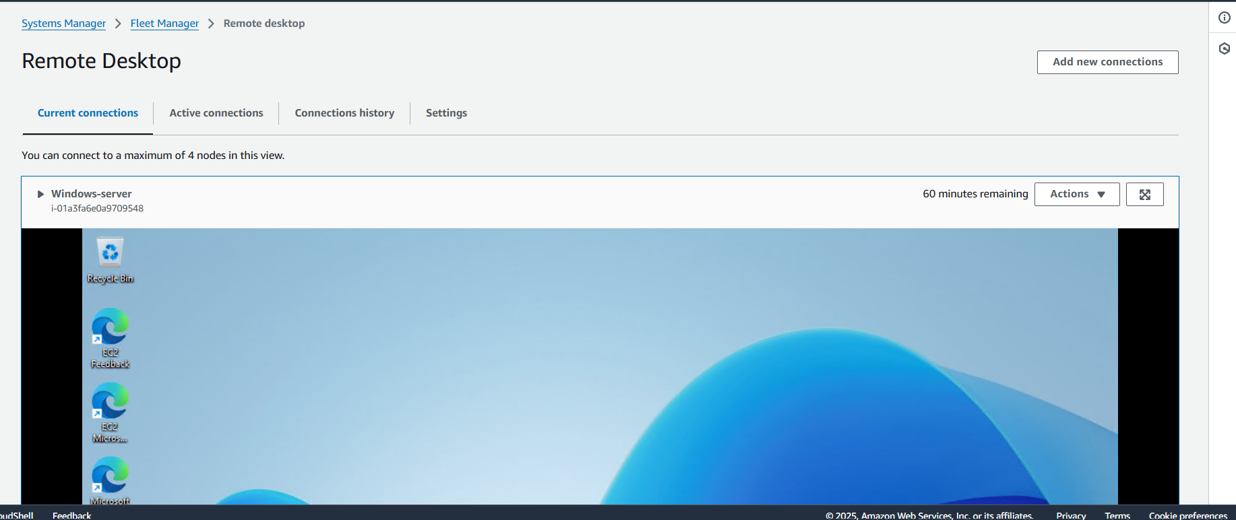

Security Notes
- Inbound HTTPS (0.0.0.0/0) is not required for SSM. The agent initiates outbound HTTPS connections.
- Avoid opening RDP (3389) to 0.0.0.0/0. Use Session Manager/Fleet Manager for secure access.
- For private subnets, use VPC endpoints for Systems Manager instead of internet/NAT.

